**JUVENILES FAMILY BACKGROUND, EDUCATION AND ECONOMIC SETUP:**

**Juveniles Education:**

ALTER TABLE "18_01_Juveniles_arrested_Education" RENAME COLUMN 'Education_Matric_or_Higher_Secondary_&_above' TO 'Education_Matric_or_Higher_Secondary_above';

Changed the column name Education_Matric_or_Higher_Secondary_&_Above to Education_Matric_or_Higher_Secondary_above.

1)

SELECT Area_Name, sum(Education_Upto_primary) as Education_upto_Primary

FROM "18_01_Juveniles_arrested_Education"

GROUP BY Area_Name

ORDER BY Education_upto_Primary DESC;

Among all states, Madhya Pradesh has the highest juveniles (27610) those are educated up to primary education.

Among all states, Manipur has no juveniles those educated up to primary education.

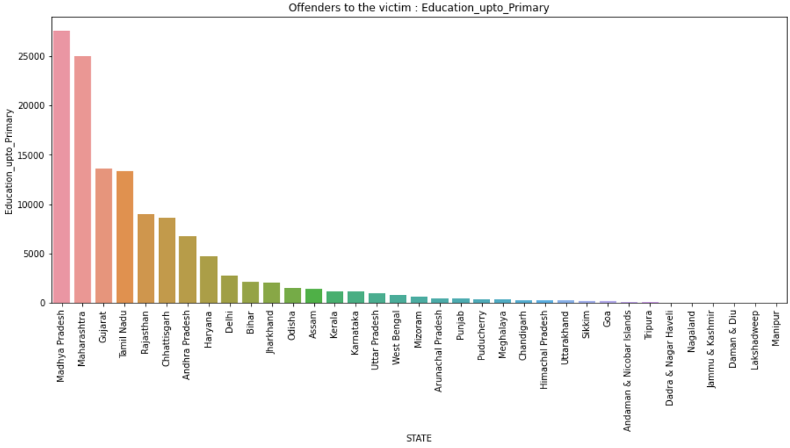

2)

SELECT Area_Name, sum(Education_Above_Primary_but_below_Matric_or_Higher_Secondary) as Education_above_Primary_and_Higher_Secondary

FROM "18_01_Juveniles_arrested_Education"

GROUP BY Area_Name

ORDER BY Education_above_Primary_and_Higher_Secondary DESC;

Among all states, Madhya Pradesh is the highest juveniles (21518) those are educated between primary and higher secondary education.

Among all states, Manipur and Lakshadweep have no juveniles those educated between primary and higher secondary education.

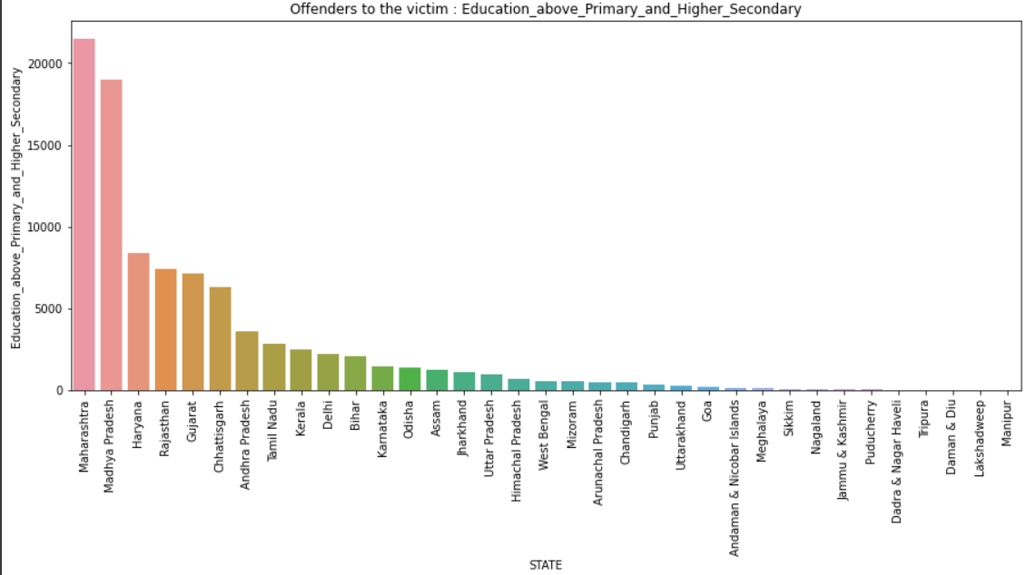

3)

SELECT Area_Name, sum(Education_Matric_or_Higher_Secondary_above) as Education_above_Higher_Secondary

FROM "18_01_Juveniles_arrested_Education"

GROUP BY Area_Name

ORDER BY Education_above_Higher_Secondary DESC;

Among all states, Madhya Pradesh is the highest juveniles (5533) those are educated above higher secondary education.

Among all states, Manipur is the no juveniles.

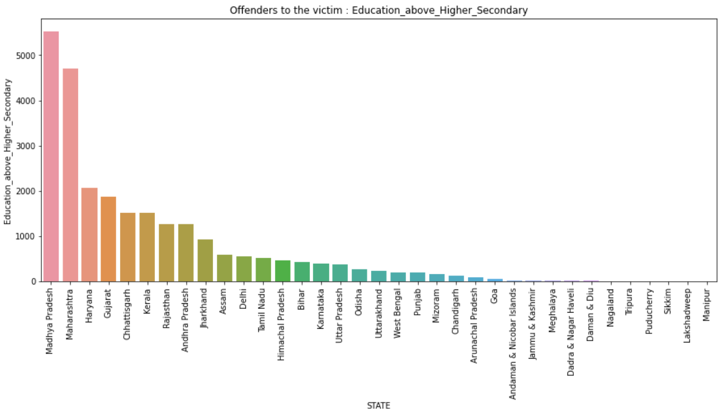

4)

SELECT Area_Name, sum(Education_Illiterate) as Education_Illiterate

FROM "18_01_Juveniles_arrested_Education"

GROUP BY Area_Name

ORDER BY Education_Illiterate DESC;

Among all states, Madhya Pradesh is the highest juveniles (19130) those are illiterate persons.

Among all states, Manipur and Lakshadweep are the no juveniles.

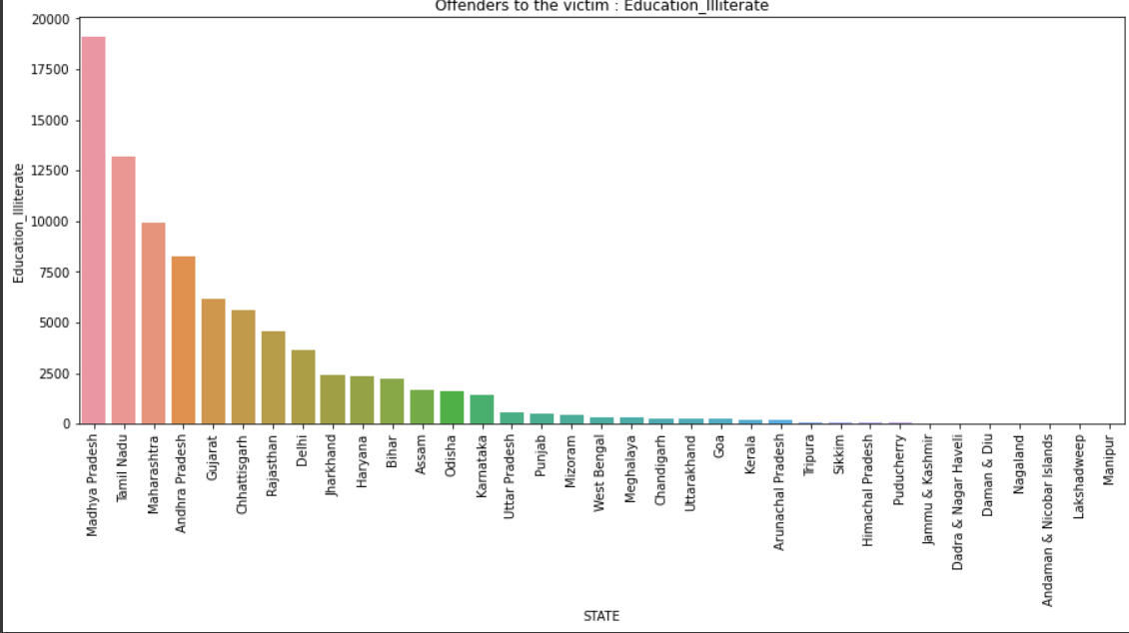

**Juveniles Family BackGround:**

SELECT Area_Name, SUM(Family_back_ground_Homeless) as Family_BackGround_Homeless

FROM "18_03_Juveniles_arrested_Family_background"

GROUP BY Area_Name

ORDER BY Family_BackGround_Homeless DESC;

Among all states, Andhra Pradesh has the highest juveniles those have no family back ground

Among all states, Manipur, Lakshadweep, Himachal Pradesh, Dadra & Nagar Haveli, Andaman & Nicobar Islands have family back ground.

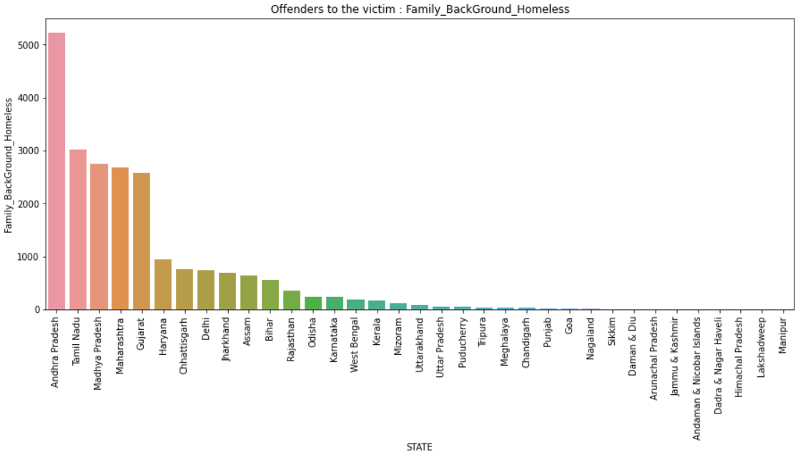

SELECT Area_Name, SUM(Family_back_ground_Living_with_guardian) as Family_BackGround_Living_with_Guardian

FROM "18_03_Juveniles_arrested_Family_background"

GROUP BY Area_Name

ORDER BY Family_BackGround_Living_with_Guardian DESC;

Among all states, Madhya Pradesh has the highest juveniles those have family background with guardian.

Among all states, Manipur, Lakshadweep, Dadra & Nagar Haveli have no family back ground with guardian.

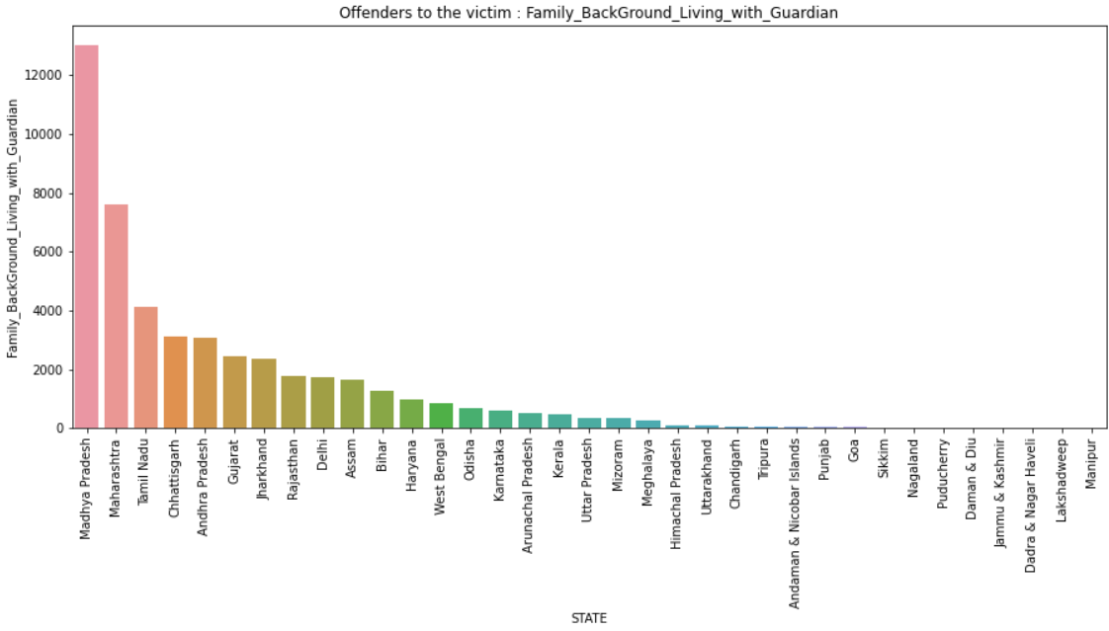

SELECT Area_Name, SUM(Family_back_ground_Living_with_parents) as Family_BackGround_Living_with_Parents

FROM "18_03_Juveniles_arrested_Family_background"

GROUP BY Area_Name

ORDER BY Family_BackGround_Living_with_Parents DESC;

Among all states, Madhya Pradesh have the highest juveniles those have family background with parents.

Among all states, Manipur have no juveniles those have family background with parents.

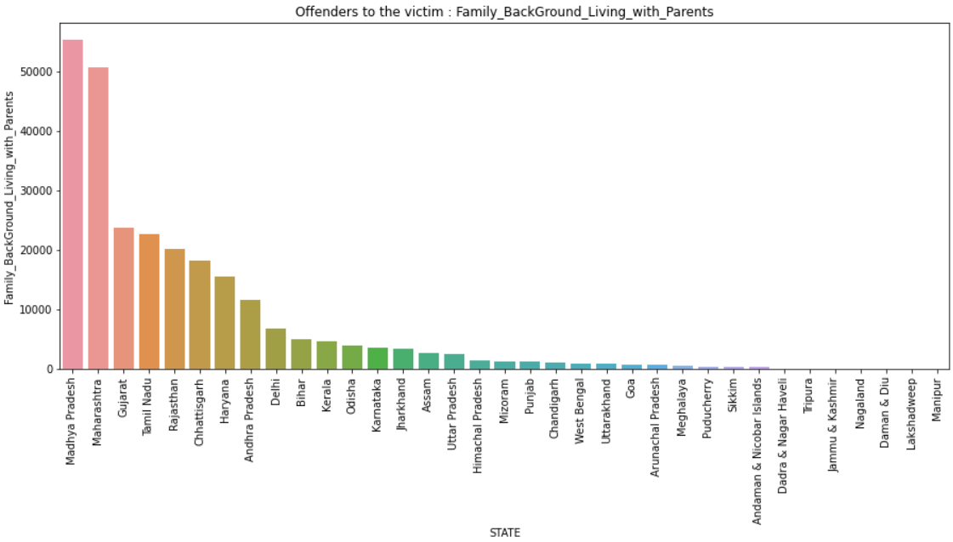

**JUVENILES ECONOMIC SETUP:**

1)

SELECT Area_Name, SUM(Economic_Set_up_Annual_Income_upto_Rs_25000) AS Economic_set_up_annual_income_upto_25000_Rs

FROM "18_02_Juveniles_arrested_Economic_setup"

GROUP BY Area_Name

ORDER BY Economic_set_up_annual_income_upto_25000_Rs DESC;

Maharashtra has highest number of juveniles have economic set up to annual income up to 25000.

Manipur has lowest number of juveniles have no economic set up to annual income up to 25000.

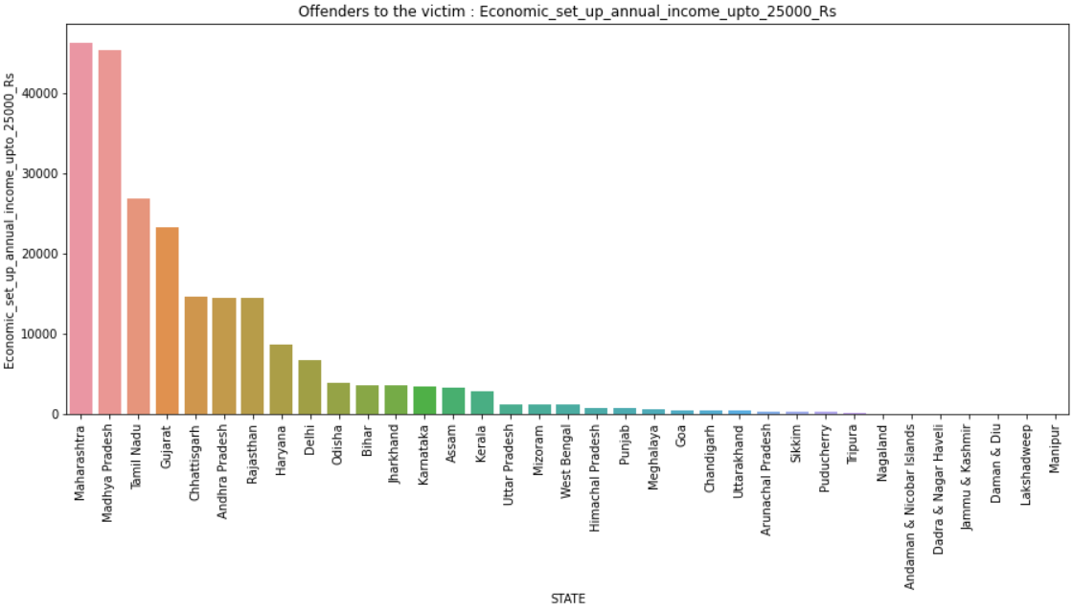

2)

SELECT Area_Name, SUM(Economic_Set_up_Annual_Income_250001_to_50000) AS Economic_set_up_annual_income_upto_Rs_25000_to_Rs_50000

FROM "18_02_Juveniles_arrested_Economic_setup"

GROUP BY Area_Name

ORDER BY Economic_set_up_annual_income_upto_Rs_25000_to_Rs_50000 DESC;

Madhya Pradesh has highest number of juveniles those have economic set up annual income from 25000 to 50000.

Manipur and Lakshadweep have no juveniles those have economic set up annual income from 25000 to 50000.

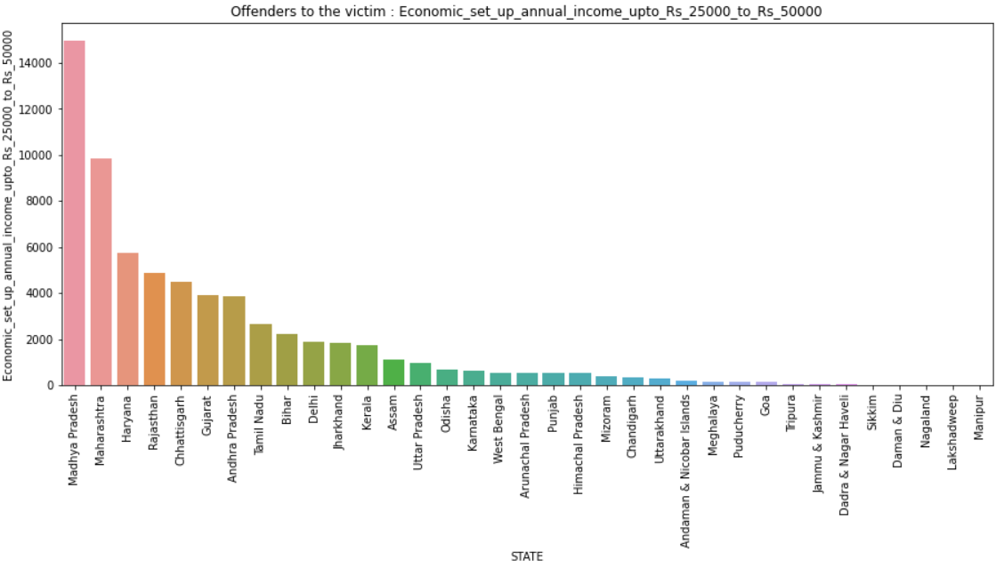

3)

SELECT Area_Name, SUM(Economic_Set_up_Middle_income_from_50001_to_100000) AS Economic_set_up_Middle_income_from_50001_to_100000

FROM "18_02_Juveniles_arrested_Economic_setup"

GROUP BY Area_Name

ORDER BY Economic_set_up_Middle_income_from_50001_to_100000 DESC;

Madhya Pradesh has highest number of juveniles have economic set up annual income from 50001 to 100000.

Manipur and Lakshadweep have no juveniles those have annual income from 50001 to 100000.

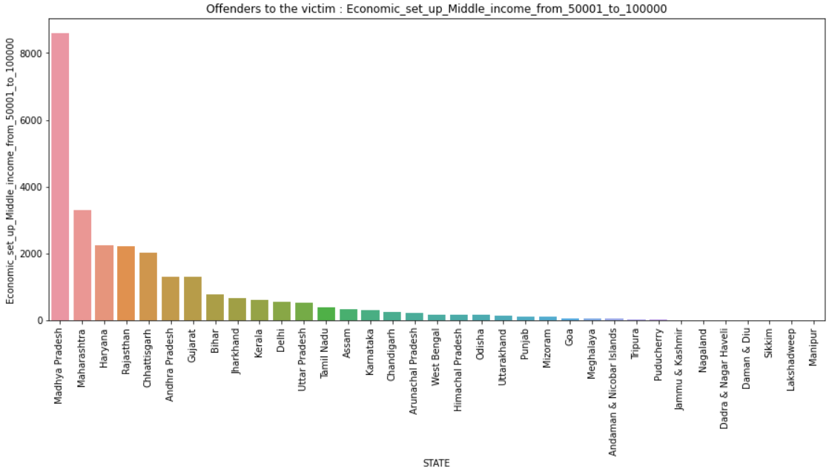

4)

SELECT Area_Name, SUM(Economic_Set_up_Middle_income_from_100001_to_200000) AS Economic_set_up_Middle_income_from_100001_to_200000

FROM "18_02_Juveniles_arrested_Economic_setup"

GROUP BY Area_Name

ORDER BY Economic_set_up_Middle_income_from_100001_to_200000 DESC;

Madhya Pradesh has highest number of juveniles those have middle income from 100001 to 200000.

Sikkim, Puducherry, Manipur, Lakshadweep have no juveniles.

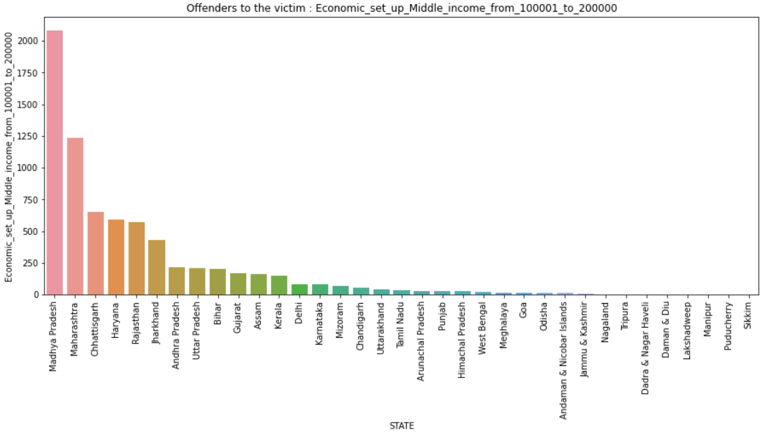

5)

SELECT Area_Name, SUM(Economic_Set_up_Upper_middle_income_from_200001_to_300000) AS Economic_set_up_Upper_middle_income_from_200001_to_300000

FROM "18_02_Juveniles_arrested_Economic_setup"

GROUP BY Area_Name

ORDER BY Economic_set_up_Upper_middle_income_from_200001_to_300000 DESC;

Maharashtra has highest number of juveniles those have middle income from 200001 to 300000.

Tripura, Sikkim, Puducherry, Manipur, Lakshadweep, Dadra & Nagar Haveli, Arunachal Pradesh, Andaman & Nicobar Islands have no juveniles that economic set up middle income from 200001 to 300000.

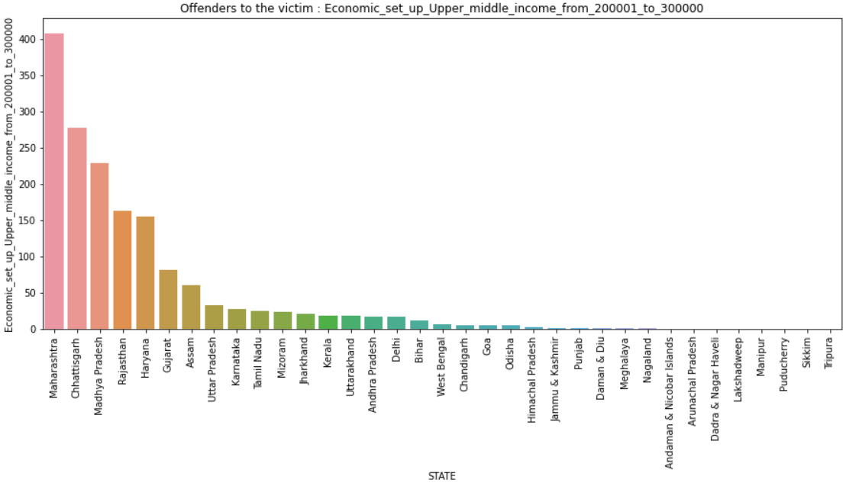

6)

SELECT Area_Name, SUM(Economic_Set_up_Upper_income_above_Rs_300000) AS Economic_set_up_Upper_income_above_Rs_300000

FROM "18_02_Juveniles_arrested_Economic_setup"

GROUP BY Area_Name

ORDER BY Economic_set_up_Upper_income_above_Rs_300000 DESC;

Madhya Pradesh has highest number of juveniles those have economic set up upper income above Rs 300000.

Uttarakhand, Tripura, Sikkim, Puducherry, Odisha, Nagaland, Meghalaya, Manipur, Lakshadweep, Kerala, Daman & Diu, Dadra & Nagar Haveli, Chandigarh, Arunachal Pradesh, Andaman & Nicobar Islands have no juveniles those economic set up upper income above Rs 300000.

